IoT Devices Authentication: Methods and Protocols
Can compromised IoT devices pose significant threats to critical infrastructure and personal privacy if not properly authenticated? Well, the answer is obvious, but another one arises. How to protect an IoT network? IoT device authentication methods safeguard the networks against unauthorized access and malicious activities.

Secure authentication methods for IoT devices vary widely in complexity and effectiveness, from traditional approaches like passwords to advanced techniques such as biometrics and digital certificates.

This article includes a detailed overview of the IoT device authentication methods and protocols, exploring their basics and ways to authenticate IoT devices.

How to authenticate IoT devices?

IoT device authentication refers to verifying the identity of connected devices within an ecosystem. This means that only authorized devices can access the network and interact with other devices or services. Authentication mechanisms range from traditional methods like passwords and tokens to more advanced techniques such as biometrics, digital certificates, and cryptographic protocols.

Implementing robust authentication measures within an IoT management platform helps organizations mitigate security risks, safeguard sensitive data, and prevent unauthorized access or malicious attacks on their IoT infrastructure. Therefore, it's crucial to consider methods and strategies for secure communication and data exchange to authenticate IoT devices effectively. Let's explore some examples in detail.

Unique device identity

It is essential to assign a distinct identity to each IoT device. This can be achieved by extracting material from the device during manufacture or injecting authentication material. Extracting identities simplifies the authentication process but can be challenging to manage at scale while injecting material involves installing a certificate authority (CA) on a microchip production line.

Authentication methods

Authentication IoT devices include passwords, certificates, tokens, and biometrics. Passwords should be strong and changed regularly, while certificates issued by trusted authorities provide a more secure option. Tokens are dynamic codes for authentication, and biometrics use physical or behavioral characteristics for verification.

Key management

Ensuring secure authentication requires management practices. This involves securely generating, storing, distributing, updating, and revoking keys or certificates using appropriate techniques.

Multi factor authentication (MFA)

When you log in, you need to provide two or more different ways to prove it's you. These can be things you know, like a password; things you have, like a special key or token; or things you are, like your fingerprint. By using these different methods together, MFA makes it much harder for someone who shouldn't be there to get in. This extra security layer helps protect against password theft and unauthorized access attempts, making your data more secure.

Top 4 authentication methods used in IoT devicesDigital certificates

Digital certificates ensure the security and trustworthiness of IoT systems. These certificates also store the necessary information to support the encryption and decryption processes used to secure communications. In simpler terms, they act as virtual passports that validate the devices and hold the keys needed to keep data safe as it travels between devices. IoT devices for businesses with large fleets managing IoT device certificates can become a logistical challenge. When a single compromised or expired certificate can interrupt service, expose private customer data, or tarnish their reputation, reliable device certificate management becomes a business-critical function.

IoT device certificates are typically X.509 certificates. It is a digital document used to authenticate client and device connections on the IoT. They contain information about the certified device, the issuing certificate authority, the public key corresponding to the device's private key, the supported encryption and digital signing algorithms, and information on the certificate's validity status.

Two-factor authentication (2FA)

Two-factor authentication in IoT is a security process where users provide two different authentication factors to verify themselves, enhancing security beyond just a password. This method requires users to provide a password as the first factor and a second different factor, such as a security token or biometric data like fingerprints or facial scans, as the second factor. By requiring two factors for authentication, 2FA significantly increases security by making it harder for unauthorized access, even if a password is compromised.

Common types of 2FA include hardware tokens, push notifications, SMS verification, and software tokens like one-time passcodes generated through apps. Hardware tokens are physical devices that produce codes for authentication, while push notifications send signals to users' phones to approve or deny access.

Root of trust (ROT)

The hardware root of trust is a concept that ensures the security of IoT devices. It involves embedding security mechanisms at the core hardware level, making it resistant to unauthorized modifications. By establishing trust from the hardware level upwards, each subsequent layer can rely on the security of the previous one, creating a chain of trust that ensures the integrity and authenticity of data exchanged between components.

RoT implementation is done through a secure element-type chip, which can securely store and perform cryptographic operations like encryption, decryption, and signature generation. This chip is a secure enclave within the device, safeguarding sensitive operations and data from unauthorized access or tampering.

Trusted platform module (TPM)

A trusted platform module (TPM) is a hardware-based security module that provides a secure foundation by storing cryptographic keys and performing security-related functions. TPMs are creating a secure foundation within a device's hardware. They are responsible for initiating a trusted starting point during the device's boot-up sequence, protecting critical operations from unauthorized interference or tampering. In essence, TPMs ensure that the device starts up securely and maintains protection for sensitive functions, enhancing overall security measures.

TPM applications boost the security of IoT gateways by enabling hardware-based root-of-trust capabilities. Integrating TPMs into devices like Linux-based edge gateways and organizations can enhance the security of IoT ecosystems by enabling secure key storage and cryptographic operations.

IoT device authentication protocolsIoT device authentication relies on protocols like Transport Layer Security (TLS), Extensible Authentication Protocol (EAP), and Pre-Shared Key (PSK). These protocols are tailored for IoT use, and employing a mix of methods across various system layers enhances security.Transport layer security protocol

Transport layer security is a cryptographic protocol designed to provide secure communication over a computer network, ensuring privacy, integrity, and authenticity through encryption and certificates. It is widely used in email, instant messaging, and HTTPS applications. TLS encrypts data and authenticates message integrity, offering security against eavesdropping and tampering. It operates above the transport layer, providing encryption for protocols like HTTP, FTP, and SMTP. TLS is crucial for securing web traffic, especially for HTTPS connections between websites and browsers.

Extensible authentication protocol

Extensible authentication protocol is an authentication framework used in network and internet connections, defined in RFC 3748 and updated by RFC 5247. It enables the transfer and utilization of data and parameters generated by the methods, which are standardized by RFCs. These methods can be either vendor-specific or new proposals developed within the industry. The EAP specifies how information is exchanged and the formats used. When EAP is used in a specific protocol, that protocol determines how to include messages within its messages.

Pre-shared key protocol

In cryptography, a pre-shared key is like a secret code shared between two parties after they've securely exchanged it before they confirm each other's identities. PSKs are commonly used in Wi-Fi encryption protocols like WEP and WPA, as well as in the Extensible Authentication Protocol, which is known as EAP-PSK. This shared key is used by both wireless access points and clients for secure communication, ensuring the confidentiality and integrity of data exchanged between systems. PSKs can be passwords, passphrases, or hexadecimal strings and are essential for establishing secure connections between devices.

Conclusion

As the IoT continues to evolve, ongoing advancements in authentication technologies will be essential to protecting connected devices and networks from emerging threats.

IoT device authentication ensures the security and integrity of IoT ecosystems. By implementing a combination of methods and protocols such as TLS, EAP, and PSK, organizations can establish robust authentication mechanisms to protect against unauthorized access and data breaches.

IoT Protocols Introduction
The IoT system can only perform and transfer information when it’s in online mode, which means the devices in IoT must be safely connected to communication networks. The question that arises is how these devices can connect and communicate with each other. The answer lies in PROTOCOLS. Protocols enable these devices to communicate effectively, and new protocols continue to be introduced regularly. In this article, we will discuss the IoT network requirements, and the different types of protocols used in IoT, and provide a brief description of commonly used protocols in the Internet of Things.

Why do we need IoT Protocols?
IoT protocols are essential for enabling seamless and efficient communication between Internet of Things (IoT) devices, applications, and services. They serve as the rules and standards that govern how devices in an IoT ecosystem exchange data and interact with each other. The need for IoT protocols arises due to several reasons:
oT Networks Requirments
Some mandatory requirements to build an IoT network are listed below:
Advertisement
- Scalable i.e. can connect a large number of devices
- Highly reliable
- Support data transmission in real time with minimized delays
- Protect data flows
- Capable of configuring applications
- Traffic management and monitoring at device level
- It should be cost-effective so that large number of devices can be connected.

IoT Protocol Types
Although, there exist a large number of IoT protocols are used in IoT. but here we will be discussing some widely used protocols in the Internet of Things which are listed below:
- MQTT (message queue telemetry transport)
- DDS (data distribution service)
- AMQP (advance message queuing protocol)
- Bluetooth
- Zigbee
- Wi-Fi
- Cellular
- LoRaWAN

Best Bitcoin Alternatives – Top 3 List
- Ethereum (ETH)
- Ripple (XRP)
- Dogecoin (DOGE)
- Sandbox (SAND)
- Solana (SOL)

Ethereum (ETH)
Ethereum is the second-largest digital currency by market cap. Ethereum started off the year 2022 with a price of $2,604.37. This cryptocurrency is a useful blockchain and has contributed largely to the development of the crypto space by hosting decentralized applications (Dapps).

Ripple (XRP)
The price of Ripple in 2022 opened approximately at $0.6. Unlike Bitcoin, Ripple (XRP) is a staking network that relies on validators to consent to newer blocks, which makes it one of the environmentally friendly alternatives. The network is one of the top 10 cryptocurrencies and its open-source protocol is fixed on a distributed ledger database and not blockchain-based.

Dogecoin (DOGE)
Dogecoin (DOGE) began the year 2022 with a price of $0.17. It is seen as a meme cryptocurrency but has been performing quite well for a while now. This cryptocurrency is ably supported by renowned technocrats like Elon Musk, the CEO of Tesla. Dogecoin does not rely on a proof-of-work protocol like Bitcoin because it uses Scrypt technology.

Libra (DIEM)
Now known as Facebook Diem, this cryptocurrency is the brainchild of numerous top-tier institutional entities like PayPal, Mastercard, Facebook, Coinbase, and Bison Trials. However, with the exit of PayPal and Mastercard, the social media giant Facebook has been an active contributor to its development. This project would implement a novel blockchain called ‘Diem’ while integrating several stablecoins to make multi-currency payments easier.
DIEM is not yet available to buy on any crypto exchange, but is expected to be in 2024.

Sandbox
Sandbox started this year with a decent price of $5.97. At the time of writing, this crypto is ranked 33 in terms of its market capitalization in the crypto ecosystem. Developed by Pixowl in 2011, the Sandbox is a pay-to-win game, where users could make, buy, and trade digital goods in a game-like environment.

Solana
In 2022, the price of Solana opened at approximately $178.52. At the time of writing, this crypto is ranked 8th in terms of its market capitalization in the crypto space. Solana has risen in value by over 100% in the last year, thereby placing itself among the top-performing cryptocurrencies.

Other Cryptocurrencies as Possible Bitcoin Alternatives
Just as we mentioned earlier, the cryptocurrency world is quite large, and newer cryptocurrencies are birthed regularly. A good number of them, although new, are backed by an excellent development team that claims them to be useful, efficient, and secure. Crypto analysts are actively studying the concept and potentials of these blockchain-based networks even as diverse institutions continue to adopt them.
Of course, the ‘best-above-all’ alternative to Bitcoin might be developed anytime soon. Nevertheless, the available options must satisfy the criteria required to be considered as useful tokens and ultimately, as perfect alternatives to Bitcoin. One of the most important criteria analysts look out for is the market cap, however, this can be swayed as newer entrants might not have a large-sized market cap just after their release.
Below are some other likely alternatives to bitcoin that have attained some of the required characteristics of a proper blockchain and are glowing of massive potential.

Litecoin (LTC)
This digital currency is often seen as the “lighter version of Bitcoin”. It has a huge market cap and operates its blockchain using Scrypt technology. Litecoin mines its blocks faster than Bitcoin, thereby ensuring that transaction speed is swift enough.

Polkadot (DOT)
Polkadot is a budding cryptocurrency that has held the attention of institutional investors for a long. This asset operates on a proof-of-stake protocol and encourages interoperability with other blockchains.

Bitcoin Cash (BCH)
Bitcoin Cash is the result of a split in Bitcoin. The hard fork emerged after Bitcoin underwent a turbulent period due to scalability issues. BCH increased its block size to eight MBs instead of Bitcoins one MB to ensure that transactions flowed easily.

Stellar Lumens (XLM)
Stellar positions as a peculiar blockchain that is structured to provide enterprise solutions via the facilitation of large transactions. Normally, traditional financial systems might take days to perform large-scale transactions but XLM performs them nearly instantly.

Binance Coin (BNB)
Initially an Ethereum-based token, BNB is the native utility token of Binance Exchange. Binance is one of the largest crypto exchanges in the world and it offers its users a discount if they trade with the BNB. The value of crypto has grown exponentially so far.

An Introduction to Bitcoin Script
Bitcoin is sometimes referred to as programmable money. Because of its digital nature, it allows users a great degree of flexibility when it comes to setting conditions for how funds can be spent.
We speak of wallets and coins when discussing Bitcoin. But we could also think of wallets as keys, coins as cheques, and the blockchain as row after row of locked safes. Each safe has a thin slot in it, such that anyone can deposit cheques or look in to see how much value the safe holds. However, only the key holder will be able to access the inside.

When a key holder wants to give money to someone else, they unlock their box. They make out a new cheque that references the older one (which is then destroyed) and lock it in a box that the recipient can open. To spend that, the new recipient repeats the process.
In this article, we’ll take a closer look at Script, the programming language interpreted by nodes on the Bitcoin network. Script is what governs the locking/unlocking mechanism mentioned for the safes.

How does Bitcoin work? Running with our analogy from above, you could say that there are two parts to every transaction – a key (to unlock your box) and a lock. You use your key to open the box that contains the cheque you want to send, and then you add a fresh one to a new box with a different lock. To spend from the new box, you need another key.
Simple enough. You can also get a bit of variation on the types of locks in the system. Maybe some safes require that you provide multiple keys, and maybe others need you to prove that you know a secret. There’s a bunch of conditions that people can set.
Our key is what we call a scriptSig. The lock is our scriptPubKey. If we look at those components in a bit more detail, we’ll find that they’re actually made up of bits of data and blocks of code. When combined, they create a tiny program.

When you make a transaction, you’re broadcasting that combination to the network. Each node that receives it will check the program, which tells it whether the transaction is valid. If not, it’ll just be discarded, and you won’t be able to spend the locked funds.

The cheques (coins) you hold are called unspent transaction outputs (UTXOs). The funds can be used by anyone that can provide the key that fits the lock. Specifically, the key is the scriptSig and the lock is the scriptPubKey.
If the UTXOs are in your wallet, they’ll probably have a condition that says only the person who can prove ownership of this public key can unlock these funds. To unlock it, you provide a scriptSig that includes a digital signature, using the private key that maps to the public key specified in the scriptPubKey. This will all become clearer shortly.

Understanding the Bitcoin stack
Script is what’s known as a stack-based language. All this means is that, when we read a set of instructions, we place them in what can be thought of as a vertical column. The list A, B, C, for example, would result in a stack with A at the bottom, and C at the top. When the instructions tell us to do something, we operate on one or more elements beginning at the top of the stack.

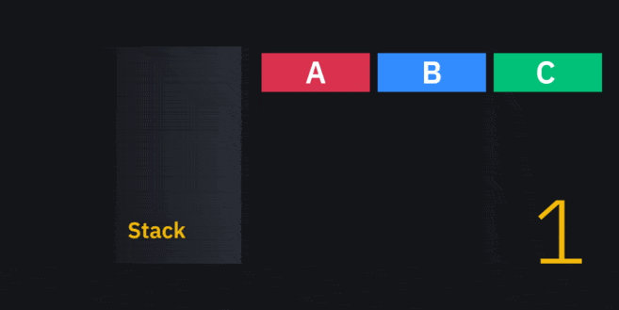
Elements A, B, and C being added and “popped” from the stack.

We can distinguish between the data (things like signatures, hashes, and public keys) and the instructions (or opcodes). The instructions remove data and do something with it. Here’s a very simple example of what a script could look like:
<xyz> <md5 hasher> <d16fb36f0911f878998c136191af705e> <check if equal>
In red, we have data, and in blue, we have the opcodes. We read from left to right, so we first put the string <xyz> onto the stack. Next up is the <md5 hasher> opcode. This one doesn’t exist in Bitcoin, but let’s say that it removes the top element of the stack (<xyz>) and hashes it using the MD5 algorithm. Then, the output gets added back onto the stack. The output here happens to be d16fb36f0911f878998c136191af705e.
What a coincidence! Our next element to add is <d16fb36f0911f878998c136191af705e>, so now our stack has two identical elements. Lastly, <check if equal> pops two elements off the top and checks if they’re equal. If they are, it adds <1> to the stack. If not, it adds <0>.
We’ve got to the end of our list of instructions. Our script could have failed in two ways – if the remaining element was a zero, or if one of the operators caused it to fail when some conditions weren’t met. We didn’t have any such operators in this example, and we end up with a non-zero element (<1>), so our script was valid. These rules hold true for real Bitcoin transactions, too.
That was just a made-up program. Let’s look at some actual ones now.

Pay-to-Pubkey (P2PK)
Pay-to-Pubkey (P2PK) is incredibly straightforward. It involves locking funds to a particular public key. If you wanted to receive funds in this manner, you would provide the sender with your public key, as opposed to a Bitcoin address.
The very first transaction between Satoshi Nakamoto and Hal Finney in 2009 was a P2PK one. The structure was heavily used in the early days of Bitcoin, but nowadays, Pay-to-Pubkey-Hash (P2PKH) has largely replaced it.
The locking script for a P2PK transaction follows the format of <public key> OP_CHECKSIG. Simple enough. You might have guessed that OP_CHECKSIG checks for a signature against the provided public key. As such, our scriptSig is going to be a simple <signature>. Remember, the scriptSig is the key to the lock.

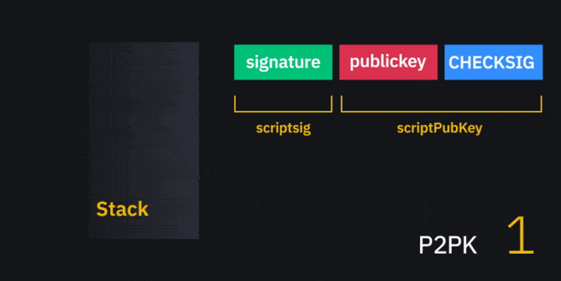

It doesn’t get much simpler than this. A signature gets added to the stack, followed by a public key. OP_CHECKSIG pops them both and verifies the signature against the public key. If they match, it adds a <1> to the stack. Otherwise, it adds a <0>.
For reasons we’ll elaborate on in the next section, P2PK isn’t really used anymore.

Pay-to-Pubkey-Hash (P2PKH)
Pay-to-Pubkey-Hash (P2PKH) is now the most common type of transaction. Unless you’re going out of your way to download archaic software, your wallet is likely doing these by default.
The scriptPubKey in P2PKH is the following:
OP_DUP OP_HASH160 <public key hash> OP_EQUALVERIFY OP_CHECKSIG
Before we introduce the scriptSig, let’s break down what the new opcodes will do:

OP_DUP
OP_DUP pops the first element, and duplicates it. Then, it adds both back to the stack. Typically, this is done so that we can do an operation on the duplicate without affecting the original.

OP_HASH160
This pops the first element and hashes it twice. The first round will hash with the SHA-256 algorithm. The SHA-256 output is then hashed with the RIPEMD-160 algorithm. The resulting output is added back onto the stack.

OP_EQUALVERIFY
OP_EQUALVERIFY combines two other operators – OP_EQUAL and OP_VERIFY. OP_EQUAL pops two elements and checks if they’re identical. If they are, it adds a 1 to the stack. If not, it adds a 0. OP_VERIFY pops the top element and checks if it’s True (i.e., non-zero). If it isn’t, the transaction fails. Combined, OP_EQUALVERIFY causes the transaction to fail if the top two elements don’t match.
This time, the scriptSig looks like this:
<signature> <public key>
You need to provide a signature and the corresponding public key to unlock P2PKH outputs.

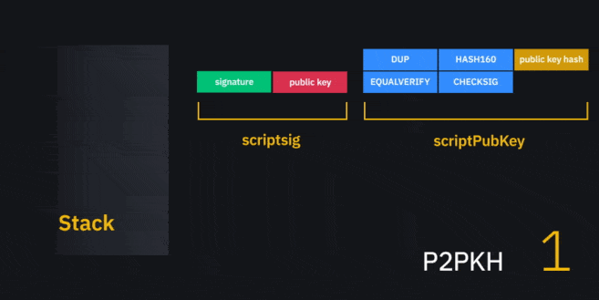

You can see what’s going on in the above GIF. It’s not too different from a P2PK script. We’re just adding an extra step to check that the public key matches the hash in the script.
There is something to note, however. In a P2PKH locking script, the public key is not visible – we can only see its hash. If we go to a blockchain explorer and look at a P2PKH output that hasn’t been spent, we can’t determine the public key. It’s only revealed when the receiver decides to transfer the funds.
This has a couple of benefits. The first is that the public key hash is simply easier to pass around than a full public key. Satoshi launched it in 2009 for this very reason. The public key hash is what we know as a Bitcoin address today.
The second benefit is that public key hashes could provide an additional layer of security against quantum computing. Because our public key is not known until we spend the funds, it’s even more difficult for others to compute the private key. They’d have to reverse the two rounds of hashing (RIPEMD-160 and SHA-256) to get it.

Pay-to-Script-Hash (P2SH)
Pay-to-Script-Hash (P2SH) was a very interesting development for Bitcoin. It allows the sender to lock funds to the hash of a script – they don’t need to know what the script actually does. Take the following SHA-256 hash:
e145fe9ed5c23aa71fdb443de00c7d9b4a69f8a27a2e4fbb1fe1d0dbfb6583f1
You don’t need to know the hash’s input to lock funds to it. The spender, however, needs to provide the script that was used to hash it and needs to satisfy the conditions of that script.
The above hash was created from the following script:
<multiply by 2> <4> <check if equal>
If you want to spend the coins tied to that scriptPubKey, you not only provide those commands. You also need a scriptSig that makes the completed script evaluate to True. In this example, that’s an element that you <multiply by 2> to give a result of <4>. Of course, that means our scriptSig is just <2>.
In real life, the scriptPubKey for a P2SH output is:
OP_HASH160 <redeemScript hash> OP_EQUAL
No new operators here. But, we do have <redeemScript hash> as a new element. As the name suggests, it’s a hash of the script we need to provide to redeem the funds (called the redeemScript). The scriptSig will change depending on what’s in the redeemScript. Generally, though, you’ll find that it’s some combination of signatures and the attached public keys, followed by the (mandatory) redeemScript:
<signature> <public key> <redeemScript>
Our evaluation differs a bit from the stack execution we’ve seen so far. It happens in two parts. The first simply checks that you’ve provided the correct hash.

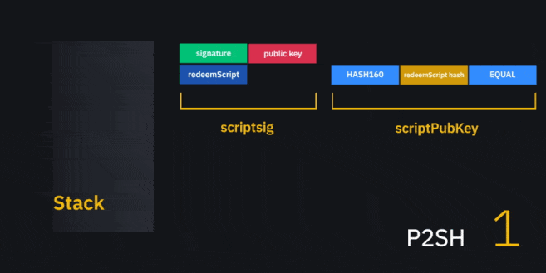

You’ll note that we don’t do anything with the elements preceding the redeemScript. They’re not used at this point. We’ve reached the end of this mini-program, and the top element is non-zero. That means it’s valid.
We’re not done yet, though. Network nodes recognize this structure as P2SH, so they’ve actually got the scriptSig’s elements waiting in another stack. That’s where the signature and public key will be used.
So far, we’ve treated the redeemScript as an element. But now, it’ll be interpreted as instructions, which could be anything. Let’s take the example of a P2PKH locking script, to which we must provide the <signature> and <public key> that matches a <public key hash> inside the <redeemScript>.

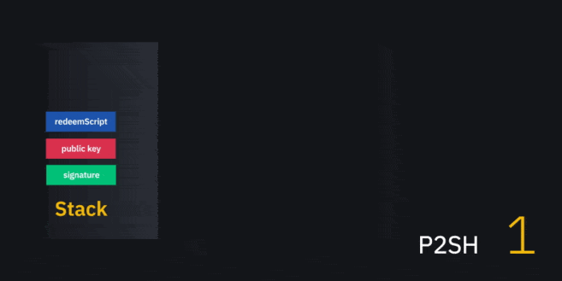

Once your redeemScript has been expanded, you can see that we have a situation that looks exactly like a regular P2PKH transaction. From there, you just run it as you would a normal one.
We’ve demonstrated what’s called a P2SH(P2PKH) script here, but you’re unlikely to find one of those in the wild. Nothing’s stopping you from making one, but it gives you no added benefits and ends up taking up more space in a block (and, therefore, costs more).
P2SH generally comes in handy for things like multisignature or SegWit-compatible transactions. Multisig transactions can be very large in size as they might require multiple keys. Prior to the implementation of Pay-to-Script-Hash, a sender would have to list all of the possible public keys in their locking script.
But with P2SH, it doesn’t matter how complex the spending conditions are. The redeemScript’s hash is always of a fixed size. The costs are therefore passed onto the user(s) who want to unlock the locking script.
SegWit compatibility is another case where P2SH comes in handy (we’ll get into the details of how the transaction structure differs in the next section). SegWit was a soft fork that resulted in a change to block/transaction formats. Because it’s an opt-in upgrade, not all wallet software recognizes the changes. It doesn’t matter if clients wrap the SegWit script hash in P2SH. As with all transactions of this type, they don’t need to know what the unlocking redeemScript will be.

SegWit Transactions (P2WPKH and P2WSH)
For a more comprehensive introduction to SegWit, check out A Beginner’s Guide to Segregated Witness.
To understand the transaction format in SegWit, you just need to know that we no longer just have a scriptSig and a scriptPubKey. Now, we also have a new field called the witness. The data we used to keep in the scriptSig is moved to the witness, so the scriptSig is empty.
If you’ve come across addresses beginning with ‘bc1’, those are what we call SegWit-native (as opposed to just SegWit-compatible, which begin with a ‘3’ since they’re P2SH addresses).

Pay-to-Witness-Pubkey-Hash (P2WPKH)
Pay-to-Witness-Pubkey-Hash (P2WPKH) is the SegWit version of P2PKH. Our witness looks like this:
<signature> <public key>
You’ll note that this is the same as the scriptSig from P2PKH. Here, the scriptSig is empty. Meanwhile, the scriptPubKey resembles the following:
<OP_0> <public key hash>
That looks a bit strange, doesn’t it? Where are the opcodes to let us compare the signature, public key and its hash?
We’re not showing additional operators here, because nodes that receive the transaction know what to do with it based on the length of <public key hash>. They’ll calculate the length and understand that it must be run in the same style as a good ol’ fashioned P2PKH transaction.
Non-upgraded nodes don’t know how to interpret the transaction in that manner, but it doesn’t matter. Under the old rules, there is no witness, so they read an empty scriptSig and some data. They evaluate this and mark it as valid – as far as they’re concerned, anyone could spend the output. This is why SegWit is considered a backward-compatible soft fork.

Pay-to-Witness-Script-Hash (P2WSH)
Pay-to-Witness-Script Hash (P2WSH) is the new P2SH. If you’ve made it this far, you can probably figure out how this will look, but we’ll run through it anyway. Our witness is what we’d normally put in the scriptSig. In a P2WSH that wraps a P2PKH transaction, for instance, it might look something like this:
<signature 1> <public key>
Here’s our scriptPubKey:
<OP_0> <script hash>
The same rules hold. SegWit nodes read the length of the script hash and determine that it’s a P2WSH output, which is evaluated similarly to P2SH. Meanwhile, old nodes just see it as an anyone-can-spend output.

Closing thoughts
In this article, we’ve learned a bit about the building blocks of Bitcoin. Let’s summarize them quickly:

Script type | Description
Pay-to-Pubkey (P2PK) | Locks funds to a particular public key
Pay-to-Pubkey-Hash (P2PKH) | Locks funds to a particular public key hash (i.e., an address)
Pay-to-Script-Hash (P2SH) | Locks funds to the hash of a script that the recipient can provide
Pay-to-Witness-Pubkey-Hash (P2WPKH) | The SegWit version of P2PK
Pay-to-Witness-Script-Hash (P2WSH) | The SegWit version of P2SH

Once you dig deeper into Bitcoin, you begin to understand why it has so much potential. Transactions can be made up of many different components. By manipulating these building blocks, users have a great deal of flexibility when it comes to setting conditions on how and when funds can be spent.

